1. Read assignment requirements and play with the sample code.

2. Create a web application with “Individual User Accounts” authentication.

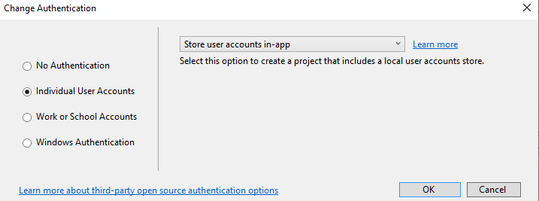

3. Added the items.cs class and the Sales.cs class and scaffolded it with entity

framework, using the existing security context, then added the migration and

updated the database, then add the controller and action names to _Layout.cshtml.

4. Edit action ‘index’ in items controller in a way that the index function take a string as its parameter, and it compares the string with each item name from ‘_context.items’ within the function, then it returns the matched results.

5. Scaffold identity into an MVC project with authorization. To add ‘identity’ scaffold to the project, select the existing layout page and data context, then select 1 file to override.

<https://docs.microsoft.com/en-us/aspnet/core/security/authentication/scaffold-identity?view=aspnetcore-3.1&tabs=visual-studio#scaffold-identity-into-an-mvc-project-with-authorization>